A1307--Asia-Indus-Idol Figure-terracotta-2000-1500 BCE

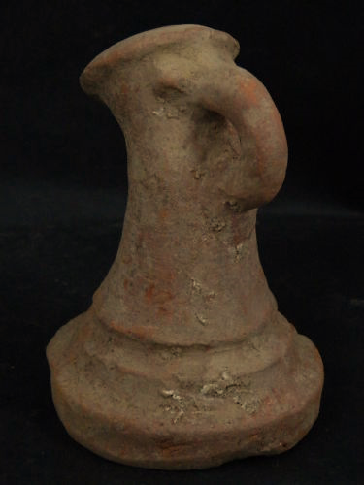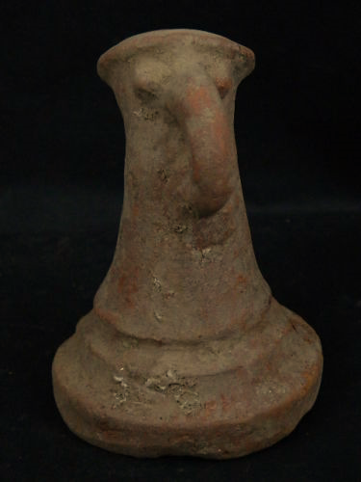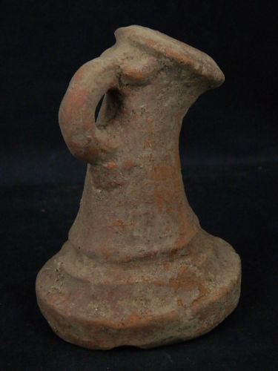 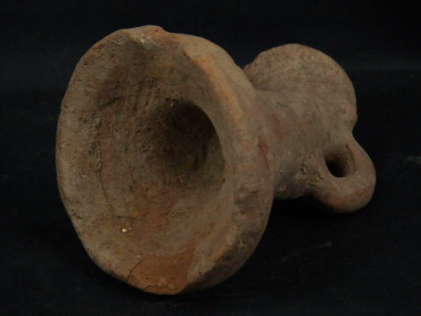

**Accession Number:** A1307

**Case no.:** 3

**Formal Label:** Indus Valley-Figurine-Abstract Avian figurine-2800 BCE-2600 BCE

**Display Description:**

This abstract avian terracotta figurine, has a curved beak that extends from its nasal origin to its mouth. Its eyes are round orbs that protrude. It has been cast with a conical body with an everted, molded base. Its function can only have been ritualistic. Being made of terracotta, it has originated with the Earth but its aspirations are with the heavens. An archetypal abstract avian in Indus civilization appears to be projected as a local female divinity. The cult of local female avian worship, is associated with the cult of the dead as raptors were seen a birds that excarnated the bodies of the deceased and by so doing ingested their spirits and their wisdom. This is the exact same impulse behind head-hunting in the tribes of Papua New Guinea.

**Cultural Affiliation:** Indus

Medium: terracotta

**Dimensions:** H 92.93 mm, 3.65 in

**Weight:** 169g, 5 7/8 oz

**Condition:** original

**Provenance:** part of an old collection

**Discussion:**

In this respect this figurine is the inversion of other female avian figurines that were associated with life-giving properties.

**References:**

Atre, Shughangana. 1987. The Archetypal Mother: A Systematic Approach to Harappan Religion. Pune: Ravish Publishers.

Bailey, Donald M. 1997. “Terracotta Figurines of Eastern Gujarat”. In Ian Freestone and David Gamester, eds., Pottery in the Making: Ceramic Traditions. Washington, D.C.: Smithsonian Institution Press.

Bhattacharyya, N. N. 1999. The Indian Mother Goddess. New Delhi: Manohar.

AP: 6.5, Barakat Gallery: London